Potential Expansion of Developable Land in Pacific County's Urban Growth Areas (UGAs)

Logan Cox, Seham Kedir

Runstad Department of Real Estate, University of Washington

R E 465 Advanced Housing Studies

Professor Arthur Acolin

June 9, 2025

# Table of Contents

**Executive Summary 2**

**Introduction and Background 3**

Urban Growth Areas and Wetlands 4

Washington State Growth Management Act (GMA) 7

**Pacific County 9**

Current Local Policies and Plans 9

Local Context: Pacific County Data 11

**Interviews 13**

Cheryl Green - Architect (CM Green Design), WCDA Board Member 14

Heather Hamilton - Business Owner / Property Developer 15

Darian Sheldon - Pacific County Health & Human Services Program Manager 16

**Case Studies: Analyzing Regulations, Processes, and Initiatives in Other Jurisdictions 17**

Yakima Nation 17

SB 5593 and Naches, WA 18

Thurston County 20

King County 21

**Recommendations 23**

Challenges Identified and Possible Solutions 23

Primary Recommendation: Phased, Transparent Approach 23

**Conclusion 25**

**References 27**

# Executive Summary

Pacific County is exploring ways to increase housing and development opportunities. However, significant portions of land within its Urban Growth Areas (UGAs) are wetlands protected by environmental laws, limiting development. Our project investigates the possibility of adjusting UGA boundaries by removing some wetland areas and replacing them with developable land outside the UGAs. We start by defining Pacific County’s UGAs and wetland areas. We analyze state and county policies, including the Washington State Growth Management Act (GMA) and study some statistics specific to Pacific County. We look at case studies from other counties and Indigenous Nations, and integrate insights from interviews with experts. Finally, we offer some recommendations to Pacific County.

# Introduction and Background

Pacific County comprises roughly 1,000 square miles of southwestern Washington. In 2023, it had a population of 23,750 (US Census Bureau, 2023) and this number has grown steadily for decades. Historically, Pacific County’s economy has been fueled primarily by natural resource industries, such as logging and fisheries. However, their economy has been in decline since the 1970s (Green, 2025). Both funding and zoning regulations are considerable hurdles faced by new developments in the county.

Washington State’s Growth Management Act (GMA) mandates that most new development should happen inside Urban Growth Areas (UGAs), to protect nature and farmland. Additionally, very little of Pacific County’s rural areas have access to water, sewer, and electricity utilities. Thus, any new developments outside the UGAs must have the utility lines extended to connect to the developed property, which is more expensive and time-consuming. However, much of the area inside Pacific County’s UGAs are taken up by wetlands, which have legal protections against most types of development (WSL, 2024). This makes it challenging to find sites on which to build houses, which the county needs to do to accommodate its growing population.

The primary idea our report explores is to adjust the boundaries of some of Pacific County’s UGAs to remove wetland areas and replace them with areas that have less legal protection and are less complicated to build on. Changing a UGA is a difficult and complicated process, as there are many legislative hurdles involved, and selecting which areas to add and which to remove is a complicated and important set of decisions.

## Urban Growth Areas and Wetlands

Pacific County’s UGAs and National Wetlands Inventory (NWI) areas are shown side-by-side in the maps listed below. The following legends apply:

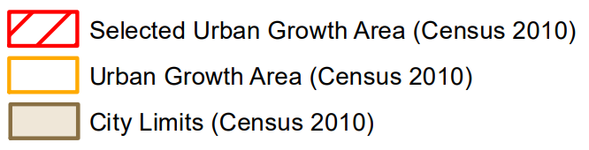

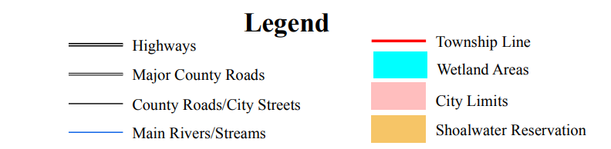

*Figure 1* (Kimpel, 2011) (Pacific County, 2004)

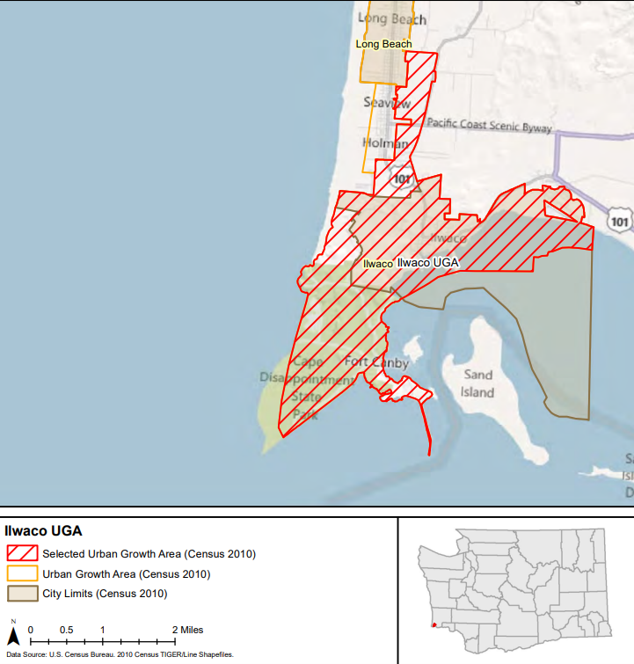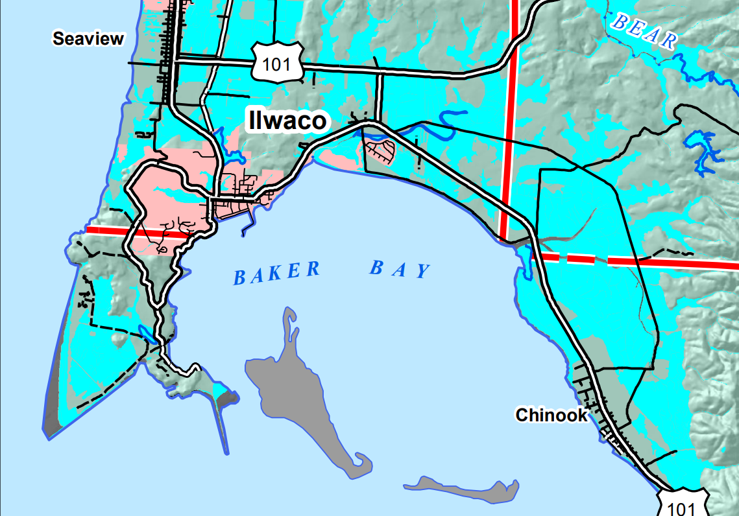*Figures 2 and 3* (Kimpel, 2011) (Pacific County, 2004)

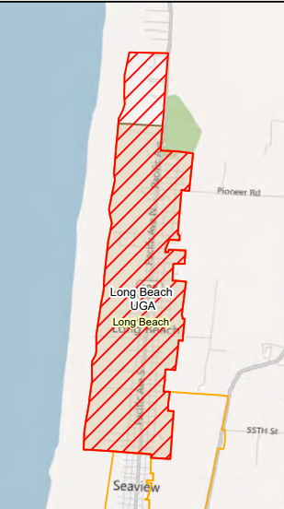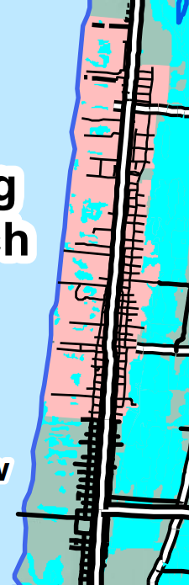

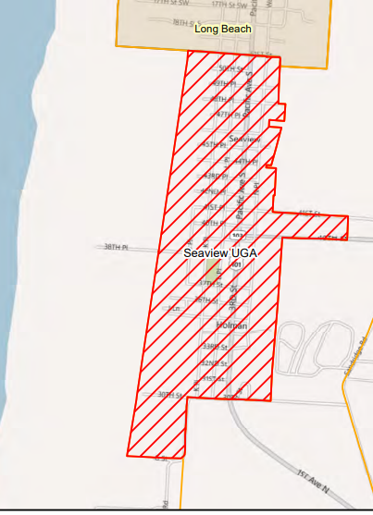

*Figures 4 and 5* (Kimpel, 2011) (Pacific County, 2004)

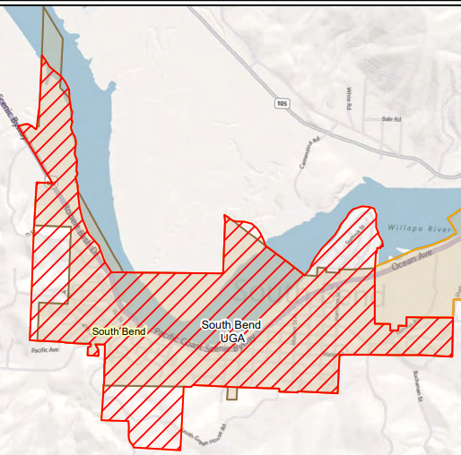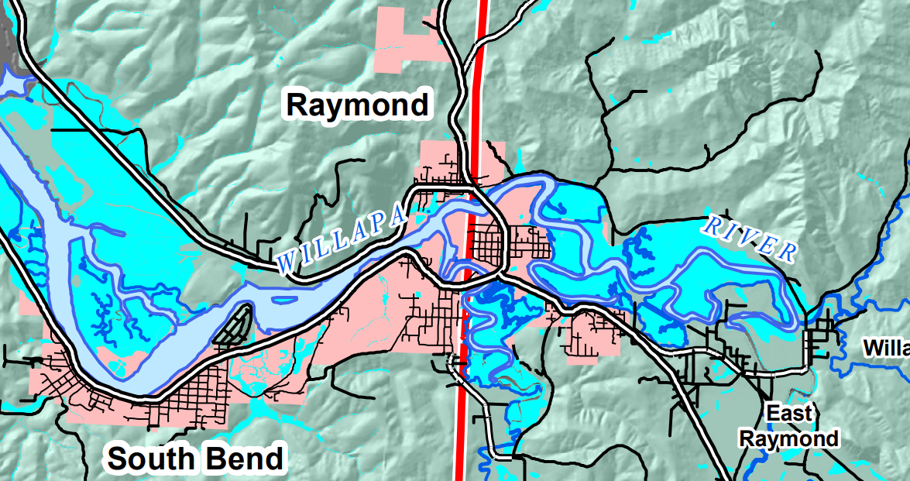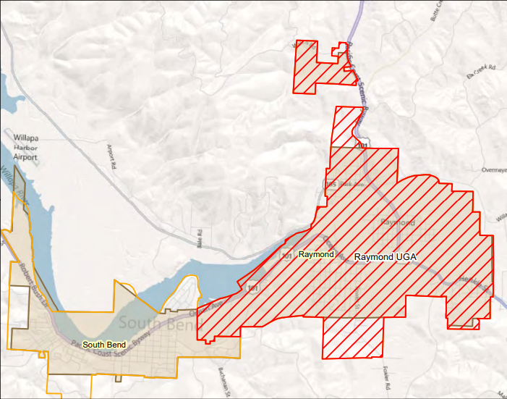

*Figures 6 (above) and 7 (below)* (Kimpel, 2011) (Pacific County, 2004)

Wetlands are ecologically important areas that provide critical habitat, water filtration, and flood control. In Washington State, wetlands are protected under multiple laws, including the Growth Management Act (WSL, 2024), Shoreline Management Act and federal Clean Water Act. These protections restrict development in wetland areas.

However, wetland mitigation programs allow for the replacement of impacted wetlands with restored or created wetlands elsewhere, often facilitated by mitigation banks. These legal frameworks must be carefully navigated when considering UGA boundary adjustments.

## Washington State Growth Management Act (GMA)

The Washington State Growth Management Act, commonly referred to as the GMA, was enacted in 1990 to address uncoordinated and often environmentally harmful growth occurring throughout the state. Its primary goal is to ensure that development happens in a way that supports long-term sustainability, protects natural resources, and reduces the negative impacts of urban sprawl. The GMA requires fast-growing counties and cities to develop comprehensive plans that guide land use, housing, transportation, economic development, and environmental protection. A central requirement of the law is the designation of Urban Growth Areas, or UGAs, where most new development must be concentrated. This strategy is designed to protect Washington’s rural lands, forests, farms, and sensitive ecosystems by directing growth toward areas that already have infrastructure and urban services. (Washington State Legislature, 2024)

For counties like Pacific County, understanding the Growth Management Act is essential when considering any changes to UGA boundaries. The GMA sets strict criteria for expanding, reducing, or otherwise modifying these boundaries. Counties must demonstrate that there is not enough suitable land within existing UGAs to meet projected housing and employment needs over a twenty-year planning horizon. They also must show that any proposed changes will not negatively impact critical areas, such as wetlands, or compromise the availability of agricultural or forest lands. Furthermore, counties must coordinate with neighboring jurisdictions and state agencies to ensure that boundary adjustments are consistent with regional growth strategies.

The GMA also includes provisions for environmental protection, including requirements for identifying and conserving critical areas like wetlands, streams, flood zones, and habitat for endangered species. These areas are often excluded from being counted as “buildable land” when counties assess their capacity for growth, which has significant implications for housing policy and land availability. (Washington State Legislature, 2024) As a result, counties must balance the need for new housing with the need to preserve ecological integrity. For Pacific County, which has a large portion of its UGAs covered by wetlands, the GMA’s rules make boundary changes particularly complex. Any attempt to adjust UGA borders by removing wetland areas and adding new land elsewhere must be backed by thorough research, data analysis, and public engagement.

Ultimately, the GMA is both a challenge and a framework for opportunity. While it imposes constraints on where development can occur, it also offers a structured path for planning growth in a responsible, equitable, and environmentally conscious way. By aligning any proposed UGA adjustments with the principles and procedures outlined in the GMA, Pacific County can position itself to increase housing supply while maintaining its commitment to sustainability and long-term community well-being.

# Pacific County

## Current Local Policies and Plans

Pacific County’s approach to growth is guided by its Comprehensive Plan, which lays out a vision for managing development while preserving the county’s natural resources and rural character. This plan emphasizes the importance of balancing economic development and population growth with environmental stewardship. One of the major constraints identified in the plan is the prevalence of wetlands within the county’s Urban Growth Areas. These wetlands limit where new housing or infrastructure can be built, which presents a challenge as the county seeks to meet rising demand for affordable housing and economic revitalization. Despite acknowledging these constraints, the county’s planning documents do not yet provide specific solutions or detailed strategies for modifying UGA boundaries or implementing wetland mitigation programs.

Pacific County’s policies generally support sustainable development practices, such as focusing growth within UGAs and protecting environmentally sensitive areas. However, in practice, local planning efforts often face difficulties when it comes to identifying available and buildable land. Interviews with county officials revealed several ongoing challenges, including administrative complexity, limited staff capacity, and the difficulty of acquiring funding in a timely manner. There are also concerns from some members of the community about the environmental and social impacts of changing UGA boundaries. These concerns include worries about overdevelopment, traffic, impacts to natural habitats, and whether infrastructure like water, sewer, and emergency services can keep up with new growth.

Recent demographic and housing data also highlight the pressures facing the county (figure 8). As of 2025, Pacific County has an estimated population of around 24,000, with a median age of 54.7, one of the highest in the state. The county has a vacancy rate of over 33 percent, with a significant portion of those units being seasonal or recreational homes that are not available to year-round residents. Meanwhile, the county has experienced a 44 percent increase in home prices over the past five years, reflecting a tight housing market with limited supply(figure 9). Many residents are employed but still struggle to meet basic needs due to rising housing costs and stagnant wages, indicating a growing need for more affordable housing options(figure 10). These trends, combined with the limited availability of developable land and lack of infrastructure in rural areas, make it increasingly urgent for the county to explore solutions such as targeted UGA boundary adjustments or land swaps through wetland mitigation.

Taken together, the current policy framework and local data suggest that Pacific County is at a critical point in its planning process. While there is broad recognition of the need for growth and housing development, existing tools and strategies may not be sufficient to meet these needs under the constraints of current land use regulations. Any successful approach will need to be informed by both the legal requirements of state planning laws and the lived experiences of local residents, while also addressing infrastructure limitations, community priorities, and environmental protection goals.

## Local Context: Pacific County Data

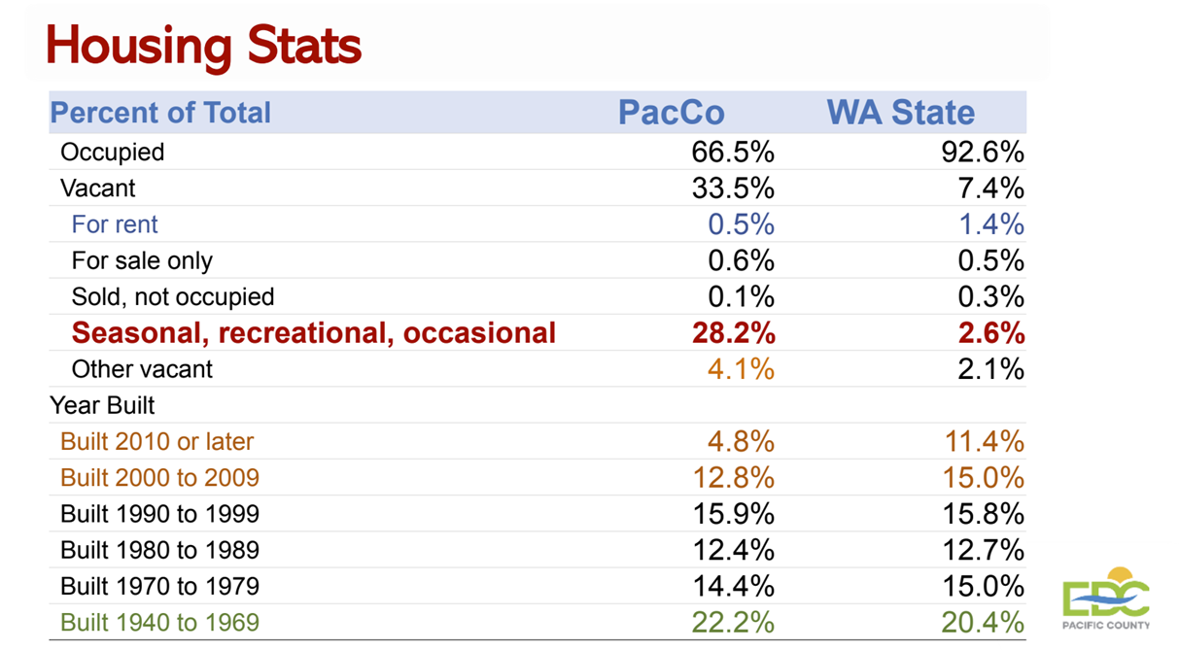

*Figure 8* (University of Washington, 2025)

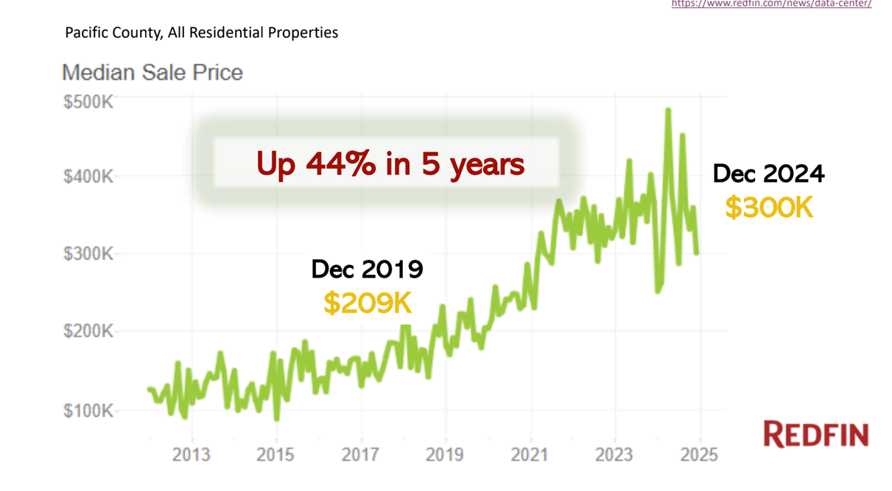

*Figure 9* (University of Washington, 2025)

The county has seen a 44% increase in home prices over the past five years, indicating rising demand and limited supply.

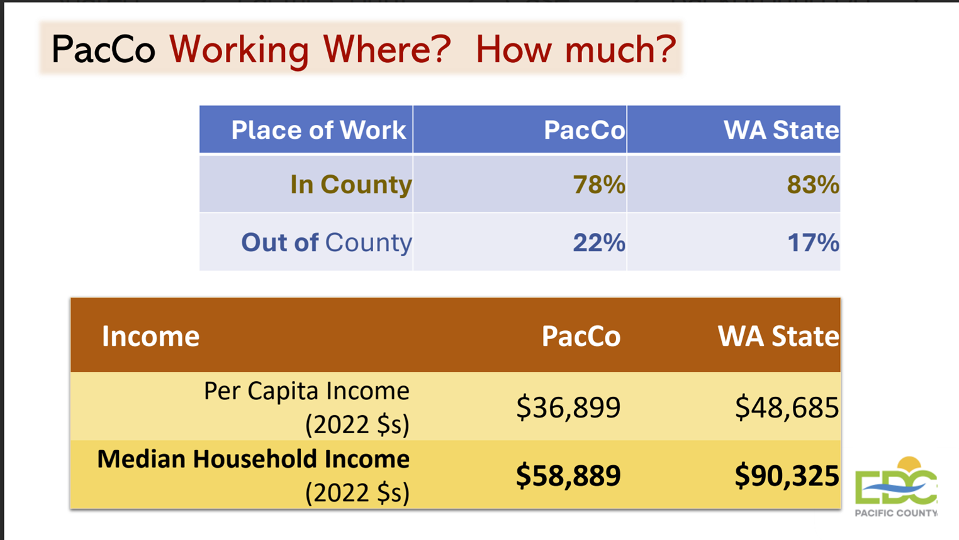

*Figure 10* (University of Washington, 2025)

These stats show that many families are working but still unable to meet basic needs, reinforcing the urgency of affordable housing development.

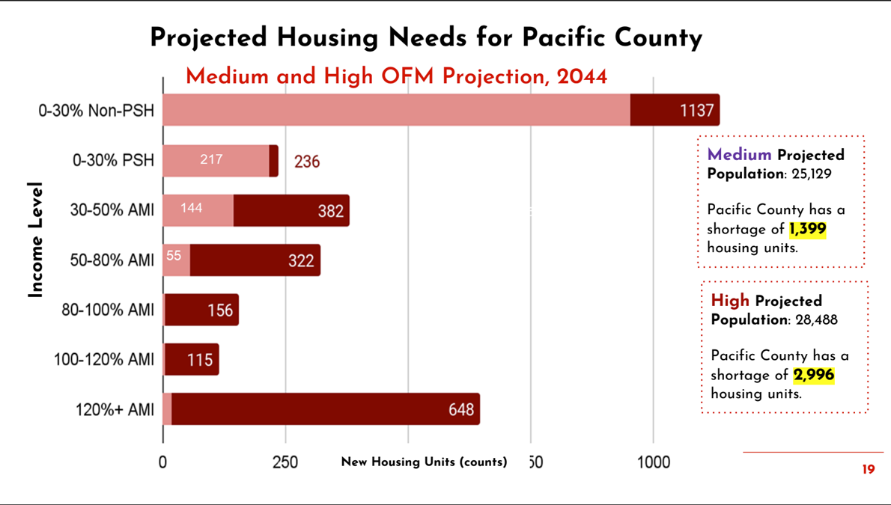

*Figure 11* (University of Washington, 2025)

Even modest growth will create a significant housing deficit unless developable land increases.

# Interviews

I (Logan Cox) interviewed three separate professionals who work with real estate in Pacific County. I asked each of them the following questions:

* As someone who works in real estate, do the wetlands in Pacific County's UGA pose a problem for you? Would it make your job easier if the UGA had more buildable land?
* Does the area you work in currently face any supply constraints that make housing development difficult?
* What rules need to be followed to remove part of a UGA?
* Are there examples of this practice that we can follow?
* What are some potential challenges with using wetland mitigation banks?
* If you were in charge of this project, what process would you follow to choose the land to replace the wetlands?
* What tools or programs have worked well in rural areas to support more housing?
* How can Pacific County balance growth with environmental protection?
* What is one of the biggest housing-related problems or obstacles that your organization faces in general?

## Cheryl Green - Architect (CM Green Design), WCDA Board Member

Cheryl Green has been working in architectural design in Pacific County since 1992. She works on many of the development projects around the county. (Green, 2025)

A primary topic Green emphasized was how much of an impact the economy had on development. She explained that the economy in Pacific County had been in decline since the late 1970s. Historically, it had been powered by natural resources (logging, fisheries, etc), but that industry no longer plays as big a role, and no other significant industries have come to take its place. As a result, Pacific County has a lower AMI than Washington State. This means that homebuyers and renters have less money to spend on housing, meaning rents and home prices have to drop to get houses sold and leases signed. Additionally, she explained that out-of-pocket investment money for developments was so scarce that most of the funding for these developments came from government grants. The combination of low funding (for investment) and low incomes (from buyers/renters) has made financially feasible development plans become increasingly scarce.

Green discussed how most new developments in Pacific County have been either housing or public resources, such as schools. She also touched on how it is much easier to secure a grant for an “affordable” housing development than a regular one.

When asked about wetlands, Green mentioned that “One-third to one-half of [her] projects are affected by wetlands.” There are ways to build on wetland areas, but they are very circumstantial and differ on a case-by-case basis. They are also heavily affected by environmentally protective legislation. Furthermore, Green claims that the definition of “wetlands” has grown over the years, and wetland-classified areas today include more land that can be developed on than they did decades ago. (Green, 2025)

## Heather Hamilton - Business Owner / Property Developer

Having years of experience as a real estate professional in Pacific County, Hamilton had a lot to say about government regulations. She responded to our interview questions over email, and some of her responses are quoted below.

*Wetlands in Pacific County’s Urban Growth Areas (UGAs) create substantial barriers to development. State laws, like the Growth Management Act, and federal mandates, such as the Clean Water Act, impose heavy-handed requirements for permits, environmental studies, and mitigation plans. These regulations often inflate costs and delay projects, undermining property owners’ ability to develop their land. For example, I’ve faced situations where county officials wrongly classified land as wetlands, forcing me to hire costly specialists to disprove their assessment. Even after demonstrating minimal environmental impact, I was still required to endure a five-year mitigation and monitoring process, which was both expensive and unnecessary. This overregulation has pushed me to invest outside Pacific County, where property rights are better respected.* (Hamilton, 2025)

Hamilton also brought up the lack of rural infrastructure outside UGAs. “[Pacific] County’s rural infrastructure—lacking adequate water, sewer, or roads—cannot support significant growth.” When asked about changing UGA borders, she brought up the county’s Comprehensive Plan and its 8-year update cycle. “UGAs are set in the county’s Comprehensive Plan, and changes typically occur during the mandated eight-year update cycle. Outside this period, amendments require a strong case to avoid bureaucratic delays.” She also cites Clark and Thurston Counties as examples to potentially follow due to them having successfully changed their UGAs to better fit developers’ needs. “Clark County has reconfigured UGAs to focus growth on buildable land, using public input and environmental reviews to justify changes while respecting property rights. Thurston County has similarly excluded environmentally constrained areas from UGAs, ensuring development occurs where it’s practical.” (Hamilton, 2025)

## Darian Sheldon - Pacific County Health & Human Services Program Manager

At Pacific County HHS, Sheldon manages housing grants and the county’s homeless response system. She began her career in human services as the Youth Homelessness Liaison for the Orange Region as part of the Youth Homelessness Demonstration Project. (Washington State Department of Commerce, 2024)

In our email interview, the problems Sheldon has had involving UGAs in her career seem similar to the ones we have seen and heard about throughout this project. “The amount of properties that are obstructed by wetlands poses a challenge for myself, our local nonprofits, and housing authority to identify viable property for affordable housing development. In addition, it limits the buildable property for private developers to build on their land and add market rate rentals/housing that can contribute to our overall housing stock for all incomes.” She also mentioned supply issues. “I have heard from our local housing authority that supply issues have pushed projects out and have become more expensive to develop.” (Sheldon, 2025)

When asked about choosing land to replace wetlands, Sheldon emphasized that land that has utilities (water/sewer/electricity) should be prioritized - a topic we have also studied. Sheldon added that “it would be important to consider if the property is just outside of the general UGA boundary. Could the property blend with the current city planning? Can we connect it to utilities rather easily, given our current utility connection map? Could road access be created if not already connected?” (Sheldon, 2025)

# Case Studies: Analyzing Regulations, Processes, and Initiatives in Other Jurisdictions

## Yakima Nation

The Yakama Nation offers a unique model that integrates cultural values with land management. They have successfully implemented land use planning that protects natural resources while allowing for residential development.

Their approach emphasizes collaborative governance, comprehensive environmental assessments, and strong community engagement. Unlike conventional zoning the Yakama Nation’s development decisions are rooted in holistic evaluations of land, water, and cultural resource impacts.

One example is their land use master plan, which includes provisions for clustered housing developments near existing infrastructure while leaving ecologically sensitive areas, such as riparian buffers and native plant habitats undeveloped. They engage in multi-stakeholders coordination with federal and state agencies to ensure their project comply with both tribal and external environmental standards. In areas with overlapping wetland zones, the nation uses seasonal water flow data and tribal ecological knowledge to determine developability, ensuring that housing does not compromise natural systems.

Pacific County can draw lessons from the Yakama Nation’s emphasis on balancing multiple goals through adaptive planning and respect for ecological constraints.

## SB 5593 and Naches, WA

SB 5593 was a Washington State bill that was signed into law by former governor Jay Inslee on June 9, 2022. (State of Washington 67th Legislature, 2022, 1) The main purpose of SB 5593 is to have local (city and county) governments do a regular review of the zoning in their jurisdiction, particularly the borders of their Urban Land Growth (ULG) area. This review includes running an annual "public participation program" in order to receive input from citizens and residents of that state or county. The local governments should then determine whether the buildable (non-wetland) areas of the ULG area are sufficient to keep up with the projected urban and population growth over the next 20 years. This piece of legislation provides an opportunity for citizens and politicians to re-draw the border of their respective ULG areas, which invites an opportunity to exclude wetlands and include other land that is more feasible/realistic to build on.

During Yakima County’s 2021 Comprehensive Plan Amendment process, the Yakima County Planning Division proposed an expansion to their Naches UGA which tried to add more developable land. Their initial proposal added eight parcels to the UGA, three of which comprising 130 Kel-Lowry Road, Naches, WA 98937, which lay adjacent to their current UGA. After being informed by the US Department of Commerce that a proposal that would increase the UGA’s land area would not be allowed if their current one allowed for 20 years of projected population growth, Yakima County submitted a revised proposal that added only 130 Kel-Lowry Road, nixed the other five parcels, and also nixed a farm which was in their current UGA and was considered unlikely to be built upon in the next 20 years. This proposal actually ended up being rejected, because an amendment was then passed that made areas designated as “agricultural, forest, or mineral resource lands of long-term commercial significance” ineligible, and 130 Kel-Lowry Road was designated as Agricultural Resource Lands. (Kuhta, 2022, 1-2) (Shinn, 2023, 1-6)

On February 21, 2023, a legal team representing the Town of Naches, its staff, and its land use consultant, Bill Hordan wrote an email to the Yakima County Planning Division essentially asking them to work with the Department of Commerce again on expanding their UGA. Their primary argument was that an updated Yakima County analysis, with new data, showed that Naches’ current UGA was actually in a deficit (would not be able to accommodate 20 years of growth), rather than a surplus as the Department of Commerce’s analysis showed. “With the newly analyzed census data, the Town has determined that the opinions offered by the Department of Commerce are now largely irrelevant…In fact, the new population census data and land quantity analysis render the need for a “land swap” not only moot, but adversely affecting the future growth needs of the Town.” (Shinn, 2023, 3) In addition to the 20-year growth “rule”, the letter also attacks the bill’s amendment regarding the rules around land swaps, calling into question the process used to classify 130 Kel-Lowry Road as Agricultural Resource Lands.

On March 8, 2023, the Yakima County Planning Commission held a hearing to vote on whether to recommend for or against expanding the Naches UGA to include 130 Kel-Lowry Road to the Board of Yakima County Commissioners. The Planning Commision voted 3 to 2 against adding 130 Kel-Lowry Road. However, two of the council members were absent, and at least four of seven votes were needed to make an official recommendation to the Board, so no recommendation was made. (Yakima County Planning Commission, 2023, 7)

This is an example of a UGA expansion/change being attempted (in this case, primarily by the local level) and ultimately failing. There was conspicuous discourse between three different levels of government - state (Department of Commerce), county (Planning Division), and local (Town of Naches). For instance, the Department of Commerce was utilizing different (older) data than Yakima County, and was using a different method of analysis. One lesson to learn from this story is that it can be hard for different levels of government to work together, so making decisions that work well with government regulations will make any process simpler and take less time. One way Pacific County could do this could be by choosing land to add to the UGA that complies with all eight requirements regarding UGA land swaps in the RCW 36.70A.130 amendment.

## Thurston County

Thurston County has emerged as a state leader in balancing housing needs with wetland protection through a structured and transparent development process. Recognizing the constraints of their own UGAs, the county developed a wetland ranking system that assigns ecological scores (ranging from high to low) to each wetland based on criteria like biodiversity, water retention, and buffer integrity. Wetlands with lower scores are more eligible for replacement or development, while high-functioning wetlands are prioritized for preservation. In parallel, Thurston County created and manages a wetlandmitigationbank, where developers can "buy credits" to offset the environmental impacts of development on low-value wetlands. This market-based approach ensures compliance with the federal “no net loss” standard while offering developers a clear legal pathway to pursue projects in constrained areas. (Thurston County, 2023)

UGA boundary adjustments in Thurston are evaluated every 8 years, but the scoring system has enabled the county to pre-identify parcels for potential swaps based on both housing need and ecological impact.

Thurston’s model provides practical tools for Pacific County to consider in managing wetland swaps. Such as implementing a clear, public scoring system for wetlands using WA Dept. of Ecology’s Wetland Rating system. create a mitigation banking framework in collaboration with the state or neighboring counties. Use the scorecard to guide community conversations and defend decisions during public hearings.

## King County

King County offers a valuable model for managing population growth and housing demand while preserving environmentally sensitive lands. Rather than expanding its Urban Growth Areas, King County focuses on encouraging infill development. This means the county places a strong emphasis on making better use of land that is already within the urban boundary. Infill development includes building housing on vacant lots, redeveloping underutilized commercial spaces, and converting older industrial areas into new mixed-use or residential communities. This approach allows the county to increase its housing supply without extending development into rural zones or critical ecological areas like wetlands and forests.

To make infill development successful, King County has introduced a number of supportive policies. One of the key strategies includes providing zoning incentives to developers. For instance, builders who include affordable housing near public transit centers may be allowed to increase the number of units they construct on a given parcel of land. The county also offers faster permit review processes for projects that meet its infill and mixed-use development goals, reducing delays and lowering costs for developers. These kinds of incentives make it more attractive for developers to focus on existing urban areas instead of pushing into land that is harder to build on or environmentally sensitive.

In addition to policy support, King County uses a detailed land evaluation system to guide development decisions. The county employs a multi-factor assessment framework that looks at four key elements. First, it considers current housing market pressures, such as rising rents or home prices, to identify areas with the greatest need for new housing. Second, it evaluates the ecological characteristics of the land, including whether it is located in a wetland, flood zone, or steep slope area, to ensure that development does not harm the natural environment. Third, the system looks at the availability of infrastructure, such as roads, electricity, water, and sewer lines, to determine whether the area can support new development. Finally, the assessment includes equity considerations by identifying areas where people are most at risk of being displaced due to gentrification or rising housing costs.

Although Pacific County has very different conditions, especially with its smaller population and more rural setting, King County’s strategies provide important lessons. In particular, the county shows how thoughtful planning and strong policy tools can help meet housing needs without expanding into undeveloped land. For towns in Pacific County like Raymond, Long Beach, or South Bend, a similar approach could involve identifying vacant or underused parcels within town limits and investing in infrastructure improvements to support new housing in those areas. This would allow the county to increase its housing stock in a way that is more cost-effective and environmentally sustainable. By prioritizing infill development and carefully evaluating land use decisions, Pacific County can address its housing challenges while still protecting the wetlands and natural landscapes that make it unique.

# Recommendations

## Challenges Identified and Possible Solutions

| **Challenges** | **Solutions** |
| --- | --- |
| Extensive wetlands within UGAs restrict developable land. | Identify and prioritize removal of low-functioning wetlands with lower ecological value. |
| Strong legal protections for wetlands complicate boundary changes. | Establish or partner with regional wetland mitigation banks to ensure legally compliant swaps. |
| Community opposition to wetland removal exists. | Engage communities early through education and transparent decision-making to build trust. |
| Lack of infrastructure in rural areas limits building capacity. | Pursue infrastructure improvements selectively, focusing on clustered housing development. |
| Complex, time-consuming UGA boundary change procedures. | Streamline UGA boundary change processes by creating clear criteria and timelines. |

*Table 1*

## Primary Recommendation: Phased, Transparent Approach

We recommend a phased and transparent approach to adjusting the boundaries of Urban Growth Areas in Pacific County. Each step builds on lessons from other counties while addressing the county’s specific challenges related to wetlands, infrastructure, and housing needs.

* Conduct a comprehensive assessment of wetland quality using ecological criteria developed by the Washington State Department of Ecology. This assessment should help identify wetlands that have lower environmental value and may be more suitable for removal or relocation, with the goal of increasing buildable land while minimizing environmental harm.
* Collaborate with state agencies, such as the Department of Ecology, and with regional partners to establish a local wetland mitigation bank. This bank would allow developers and public agencies to offset wetland impacts by restoring or preserving wetlands elsewhere in the region. Following the model used in Thurston County, this program should be overseen by a committee made up of community representatives, county officials, environmental experts, and housing advocates to ensure accountability and public trust.
* Develop and publicly share clear and consistent scoring criteria to evaluate potential wetland swaps. These criteria should incorporate factors such as ecological value, housing demand, availability of public utilities, and transportation access. A transparent scoring system will help guide decision-making and reduce conflicts among stakeholders.
* Where wetland removal is not possible or appropriate, implement incentives for clustered housing development. Encouraging more compact residential growth in already-served areas can help reduce the strain on wetlands while still increasing the overall housing supply. Programs like those supported by the Mountain Housing Council demonstrate the benefits of this strategy in rural communities.
* Enhance community engagement through a series of educational workshops, public meetings, and accessible materials that explain the purpose and process of UGA adjustments. Open and inclusive community dialogue can build public understanding and reduce opposition, especially when residents see how these changes can support local housing needs without sacrificing long-term environmental goals.
* Pursue federal and state funding sources, including infrastructure and housing development grants, to support these efforts. Targeted investment in roads, water, sewer, and electrical service in priority growth areas will make new development more feasible and cost-effective.

These recommendations aim to balance Pacific County’s growing housing needs with environmental protection goals, while remaining consistent with the Washington State Growth Management Act and wetland protection regulations established under the Washington Administrative Code.

# Conclusion

Pacific County faces a growing need for housing, but much of its Urban Growth Area land is limited by wetland protections. This report explored the possibility of adjusting UGA boundaries to remove low-functioning wetlands and replace them with more developable land, while remaining consistent with state law. Through case studies, interviews, and policy analysis, we recommend a phased and transparent approach that includes wetland assessments, community engagement, and the creation of a local mitigation bank. These steps can help the county meet housing needs without compromising environmental values. With thoughtful planning and collaboration, Pacific County can strike a balance between growth and conservation, ensuring a more sustainable and inclusive future for its residents.

# References

Green, C. (2025, May 30). *Phone interview with Logan Cox*.

Hamilton, H. (2025, May 31). Email interview with Logan Cox [Email].

Sheldon, D. (2025, May 30). Email interview with Logan Cox [Email].

Kimpel, T. (2011, October 20). *Urban growth area maps – Pacific County*. Washington State Office of Financial Management – Forecasting Division. <https://ofm.wa.gov/sites/default/files/public/dataresearch/pop/smallarea/maps/uga/saep_uga_pacific.pdf>

Thurston County. (2023). *Thurston County Comprehensive Plan*. Thurston County Government. <https://www.thurstoncountywa.gov/departments/community-planning-and-economic-development/planning/comprehensive-plan>

U.S. Census Bureau. (2023). *ACS demographic and housing estimates: Pacific County, WA (Table DP05)* [Data set]. American Community Survey, 5-Year Estimates. <https://data.census.gov/table/ACSDP5Y2023.DP05?q=population&g=050XX00US53049>

University of Washington. (2025). *PacCo Stats and Facts: Housing and population data for Pacific County* [Unpublished report]. Google Drive. <https://drive.google.com/file/d/1ZDT9EuEVvwfyRc-cnl2vSYDGIvuypJ7g/view?usp=sharing>

Washington State Legislature. (2024). *Revised Code of Washington (RCW) 36.70A: Growth Management Act*. <https://apps.leg.wa.gov/rcw/default.aspx?cite=36.70A>

Washington State Legislature. (2024). *Washington Administrative Code (WAC) 173-22: Wetland Designation*. <https://apps.leg.wa.gov/wac/default.aspx?cite=173-22>

Washington State Legislature. (2024). *Shoreline Management Act*. <https://apps.leg.wa.gov/rcw/default.aspx?cite=90.58>

Washington State Department of Ecology. (2006). *Wetlands in Washington State – Volume 1: A synthesis of the science*. <https://apps.ecology.wa.gov/publications/documents/0506006a.pdf>

Mountain Housing Council. (n.d.). *Supporting affordable housing through clustered development*. [https://www.mountainhousingcouncil.org](https://www.mountainhousingcouncil.org/)

Washington State Department of Commerce. (2024, April 16). Community Advisory Team (CAT). Washington State Department of Commerce. Retrieved June 9, 2025, from <https://www.commerce.wa.gov/housing-policy/community-advisory-team/>

State of Washington 67th Legislature. (2022, June 9). GROWTH MANAGEMENT ACT—URBAN GROWTH AREA BOUNDARY REVISIONS [AN ACT Relating to urban growth area boundaries; and reenacting and amending RCW 36.70A.130.]. Retrieved May 9, 2025, from <https://lawfilesext.leg.wa.gov/biennium/2021-22/Pdf/Bills/Session%20Laws/Senate/5593-S.SL.pdf#page=1>

Kuhta, S. (2022, October 3). Re: Naches UGA Amendment - Case LRN2021-00001. Washington State Department of Commerce. Retrieved June 9, 2025, from <https://www.yakimacounty.us/DocumentCenter/View/32752/Naches-Exhibit-1_Department-of-Commerce-Letter>

Shinn, M. F. (2023, February 21). Re: Town of Naches' Request to Amend Naches' Urban Growth Area. Halverson Northwest Law Group. Retrieved June 9, 2025, from <https://www.yakimacounty.us/DocumentCenter/View/33601/Naches-UGA-Modification-Request---February-21-2023>

Yakima County Planning Commission. (2023, April 10). Findings of Fact and Recommendation. Retrieved June 9, 2025, from <https://www.yakimacounty.us/DocumentCenter/View/34406/Findings-2023-Naches-UGA-Modified-Amendment>